CSIT314 Software Development Methodologies - Group Project

Sprint 5 - US47: Generate weekly report
Interior Design Platform - Platform Manager
All diagrams were drawn in draw.io. Open "US47 Generate weekly report.drawio" in this folder to edit them - each diagram is its own page in that file. The exported images are in the "diagrams" folder.

Assumptions
- The system is the Interior Design Platform from the project specification. Sprint 5 covers the Interior Designer's IDP view and save statistics (US37, US38) and the Platform Manager's daily, weekly and monthly IDP category reports (US46 - US48).
- We follow B-C-E: the actor only talks to the boundary (page), the boundary only talks to the controller, and the controller works with the entity classes. There is one controller per use case.
- Who checks what: the boundary checks all the input (required fields, lengths, formats, e.g. not suspending your own profile) and trims spaces, then passes an entity object on. The controller just calls the entity and returns the result. The entity checks for duplicates and the database state (e.g. name already used, only Active rows are changed), then saves. In US47 the only input is the date: the page trims it and checks it (validateDate - a real YYYY-MM-DD date, checked with datetime.strptime(selectedDate, "%Y-%m-%d") so 20261105 is rejected, and not after today). The controller just calls IDPAnalytics.getWeeklyReport(selectedDate) and returns the report unchanged. The entity works out the period itself and reads the views and saves; nothing is saved.
- Being logged in as a Platform Manager (UC39) is the precondition, so the page and the B-C-E / sequence diagrams don't check the manager again (no PlatformManagerLoginController). managerLoginRequired in app.py only sends someone with no session to /manager/login.
- Views are recorded when a customer opens an IDP (UC32 View IDP) and saves when a customer saves one (UC33 Save IDP). The report only reads them; it never changes any data.
- The report lists every IDP category, Active or Suspended, with its number of Active IDPs and the views and saves of its IDPs in the period (both ends included), ranked by views, then saves (then name). Times are stored in UTC and compared as local dates.
- The "selected week" in the user story is picked with one date: the manager picks any day and the week (Monday-Sunday) is worked out from it by the entity, not the controller. A week can cross a month or year end, e.g. 31 Dec 2025 gives 29 Dec 2025 to 04 Jan 2026. The day picked can't be after today.
- Daily, Weekly and Monthly tabs on the same page switch between US46, US47 and US48. "Reports" in the side menu opens the daily report; the dashboard links to all three.
- Wrong input never reaches the controller: a date that isn't a real YYYY-MM-DD date gives "Please choose a valid date" and a date after today gives "The date can't be in the future" (HTTP 400, the form is shown again). A period with no views and no saves still shows the table (all zeros) with "No IDPs were viewed or saved in this period".

1. User story
Story ID | US47
User story | As a platform manager, I want to generate a weekly report so that I can see which IDP categories were most popular in a selected week.
Actor | Platform Manager
Priority | Medium
Story points (estimate) | 2
Acceptance criteria | 1. Given I am logged in as a platform manager, when I click the "Weekly" tab, then I see the Weekly Category Report page with a date box ("Any day in the week") that starts on today, and no report yet.  2. Given I pick any day and click "Generate report", then I see the Monday-Sunday week of that day (e.g. 05 Nov 2026 gives "02 Nov 2026 to 08 Nov 2026") and every IDP category (Active or Suspended) with its status, number of Active IDPs, views and saves in that week.  3. The categories are ranked by views, then saves.  4. Given no IDP was viewed or saved in the period, then I see "No IDPs were viewed or saved in this period" and the table with zeros.  5. Given the date is not a real date (e.g. 2026-02-30 or 20261105), then I see "Please choose a valid date" and no report.  6. Given the date is after today, then I see "The date can't be in the future" and no report.  7. Given I am not logged in, when I open the report page, then I am sent to the manager login page.
Tasks | #265 Draw Use Case Diagram and Write Use Case Description  #270 Design Wireframe  #275 Write and Execute Test Cases  #280 Draw BCE and Sequence Class Diagram  #286 Implement the weekly report function to calculate and display IDP category popularity statistics for a selected week.

2. Use case diagram
The user story becomes one use case, UC47 Generate weekly report. The Platform Manager is the only actor. Being logged in (UC39) is the precondition; the views and saves the report counts are recorded by UC32 View IDP and UC33 Save IDP. UC46, UC47 and UC48 are the daily, weekly and monthly reports on the same page.
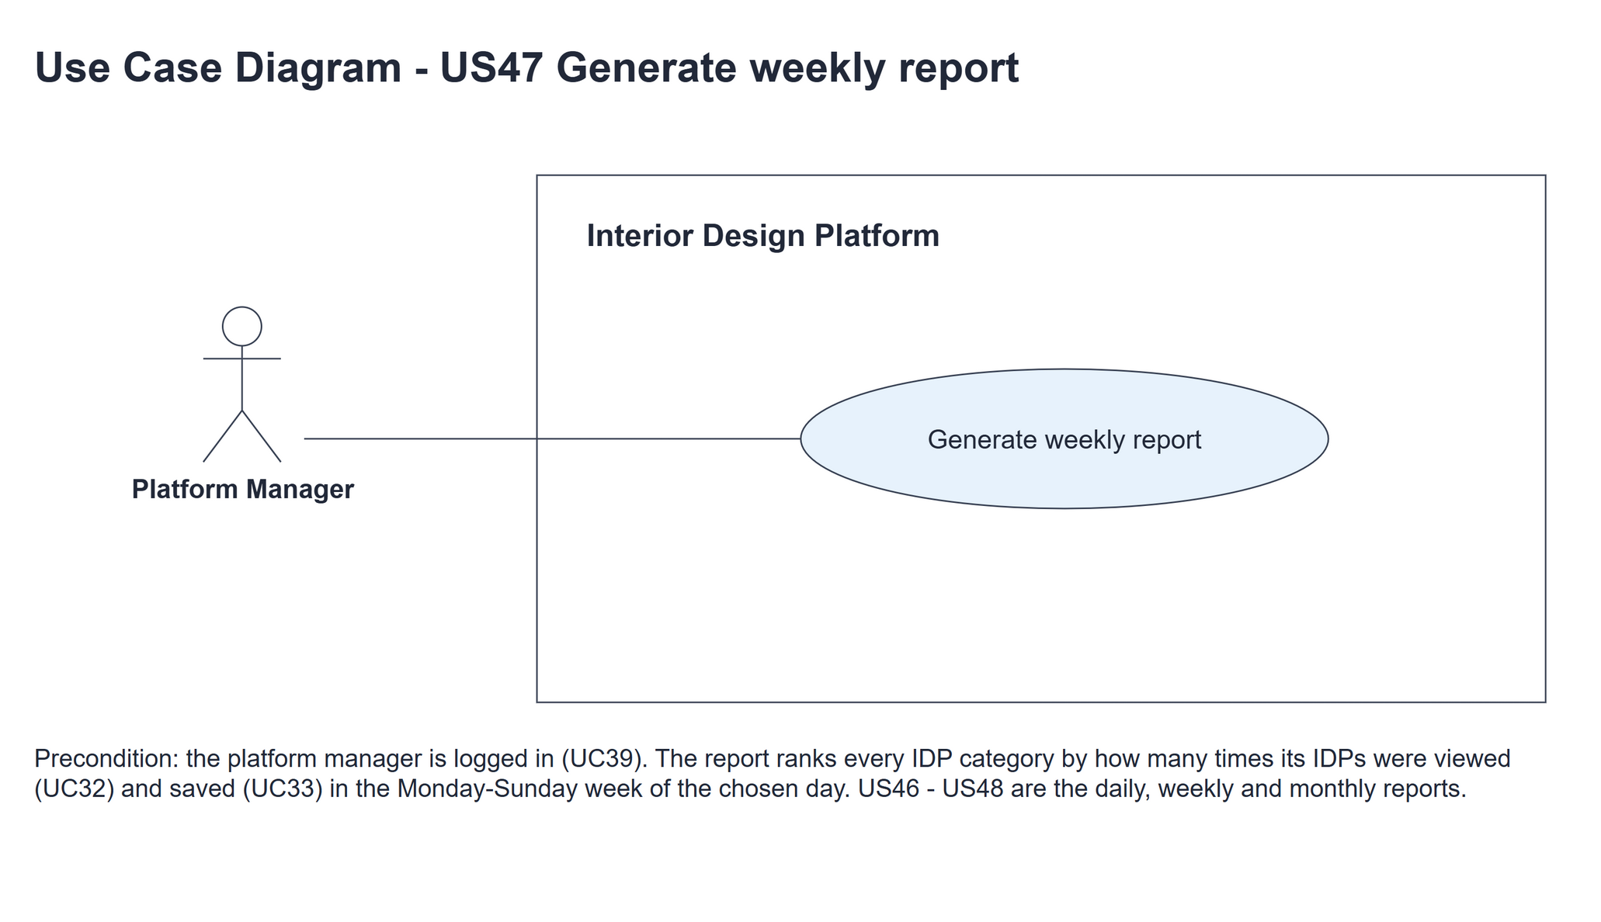
Figure 1: Use case diagram for US47 Generate weekly report

3. Use case description
Use case | UC47 Generate weekly report
Actor | Platform Manager
Brief description | The Platform Manager picks any day and sees which IDP categories customers viewed and saved most in that day's week (Monday to Sunday).
User story | US47: As a platform manager, I want to generate a weekly report so that I can see which IDP categories were most popular in a selected week.
Preconditions | Logged in as a Platform Manager (UC39). managerLoginRequired in app.py only sends someone with no session to /manager/login.
Trigger | The Platform Manager clicks the "Weekly" tab on the report page.
Basic flow | 1. The Platform Manager clicks the "Weekly" tab.  2. The system shows the report form; the date box starts on today.  3. The Platform Manager picks any day in the week ("Any day in the week") and clicks "Generate report".  4. The system trims the date and checks that it is a real YYYY-MM-DD date that is not after today.  5. The system works out the week from that day - the Monday to the Sunday of the week the day is in (a week can cross a month or year end).  6. The system counts the views and saves of every IDP category in the period and ranks the categories by views, then saves.  7. The system shows the period and the ranked table with each category's status, number of Active IDPs, views and saves.
Alternative flows | 4a. The date is not a real YYYY-MM-DD date (e.g. 2026-02-30 or 20261105): the system shows "Please choose a valid date" with the form again (HTTP 400). No report is generated. The use case ends.  4b. The date is after today: the system shows "The date can't be in the future" with the form again (HTTP 400). No report is generated. The use case ends.  7a. No IDP was viewed or saved in the period: the system shows the period, "No IDPs were viewed or saved in this period" and the table with zeros.
Postconditions | The report (or the error message) is shown. No data is changed.

4. Wireframes
The wireframes were drawn in draw.io. They are low-fidelity: they show the layout and the flow, not the final colours. They follow platformManagerBase.html, idpCategoryReport.html and static/style.css. The orange numbers match the notes under each screen.

4a - Date form
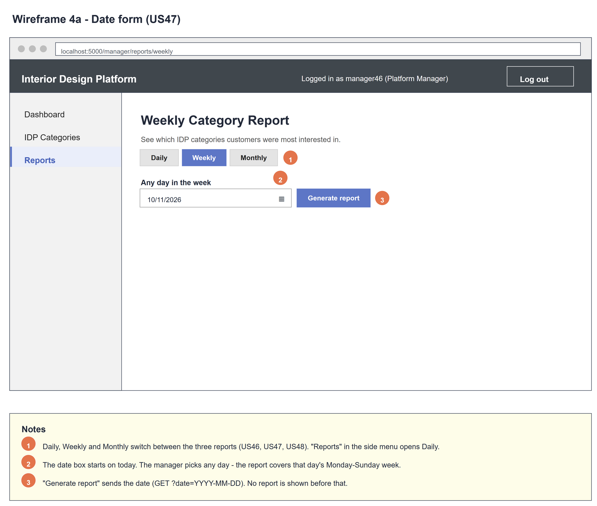
Figure 2: Wireframe 4a - Date form (US47)

4b - Report
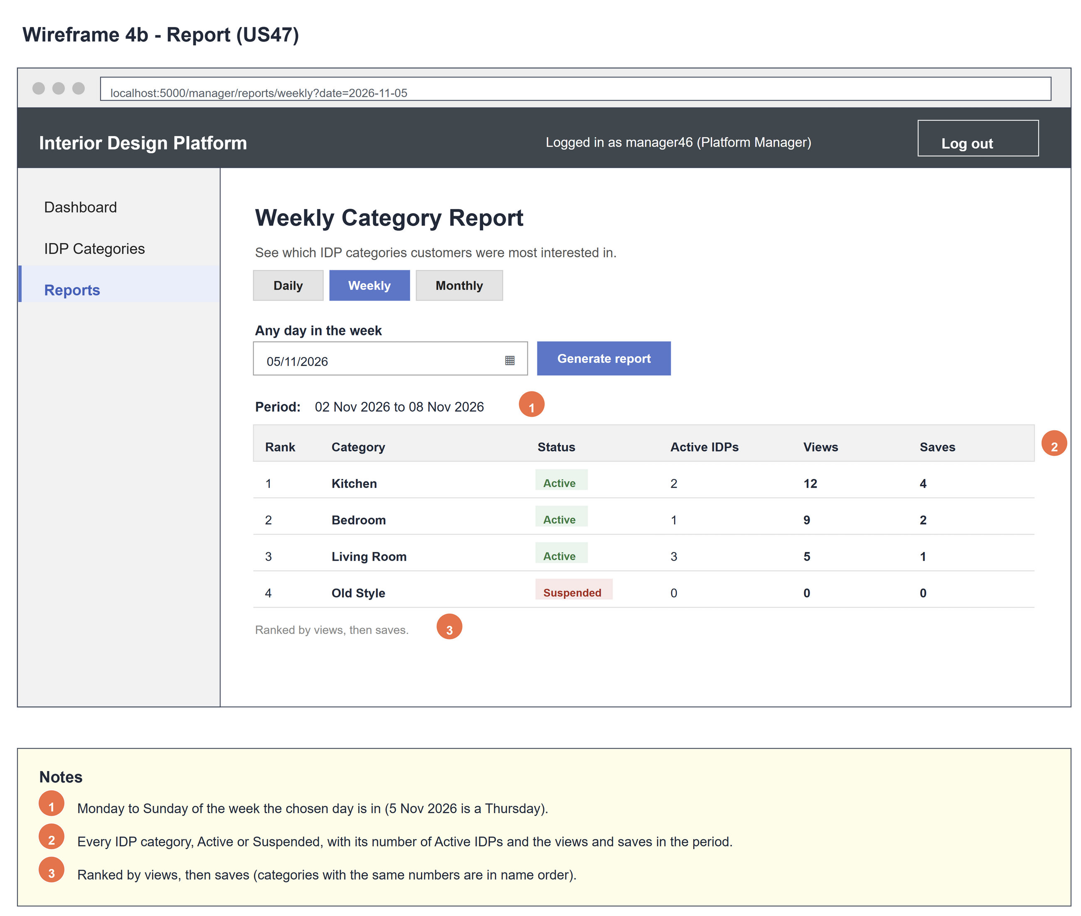
Figure 3: Wireframe 4b - Report (US47)

4c - No activity
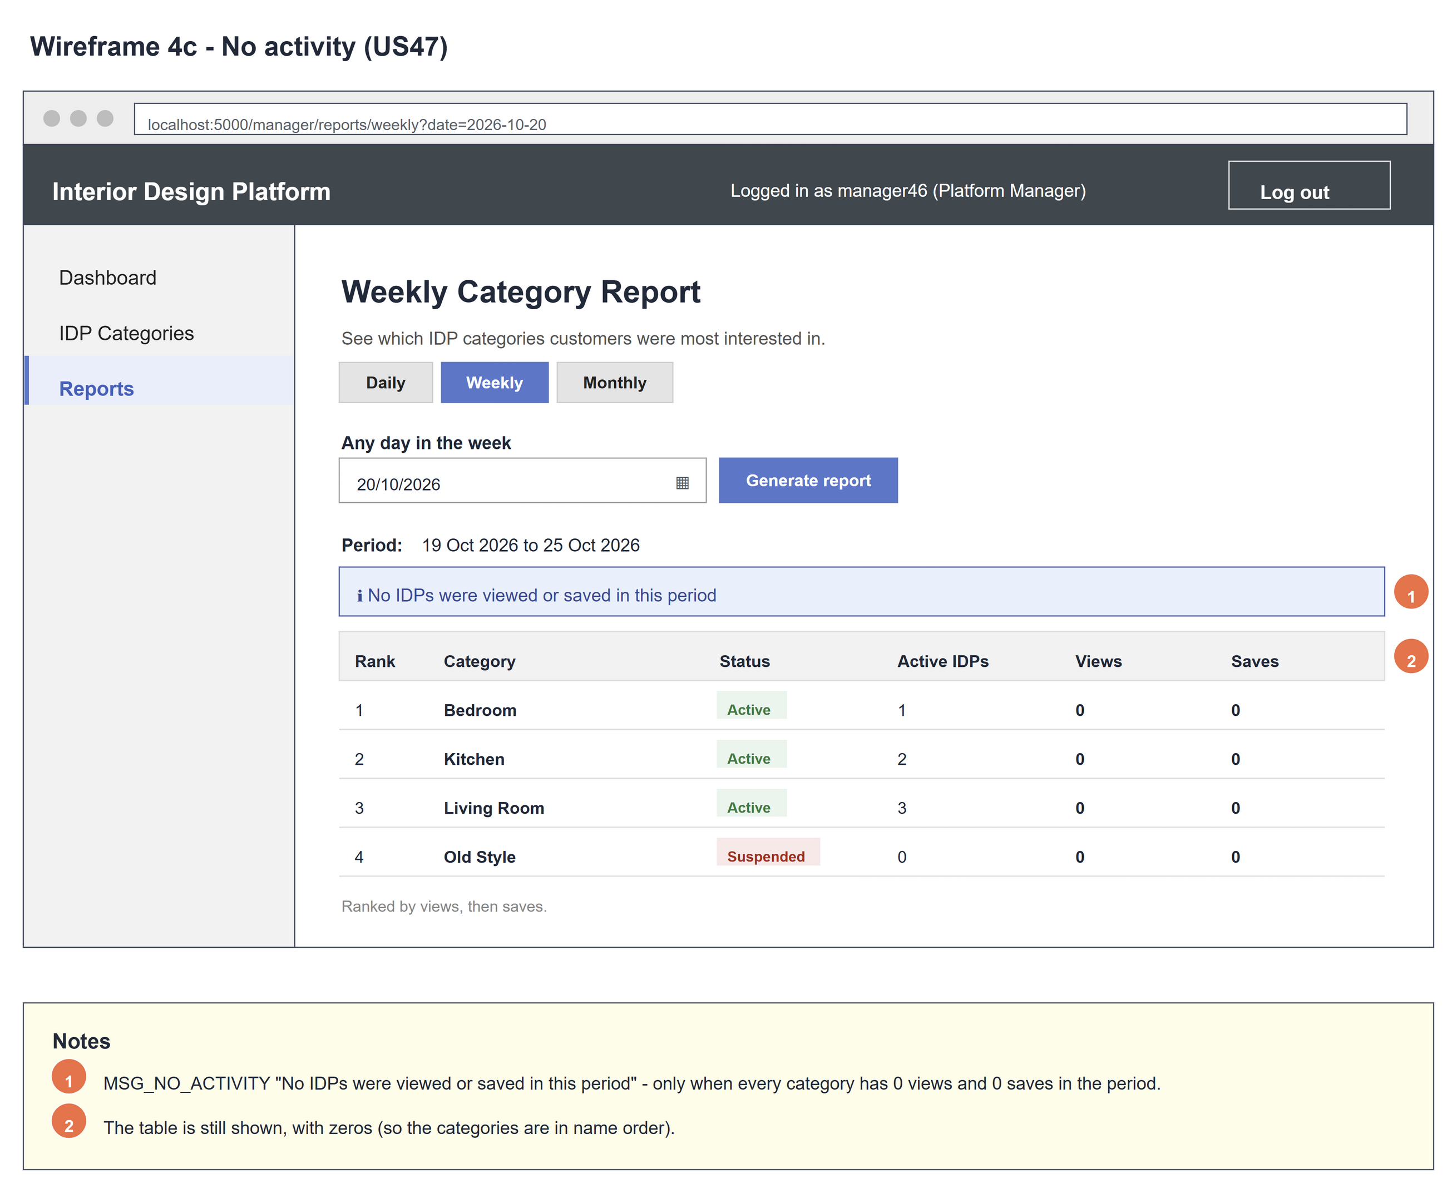
Figure 4: Wireframe 4c - No activity (US47)

4d - Invalid date
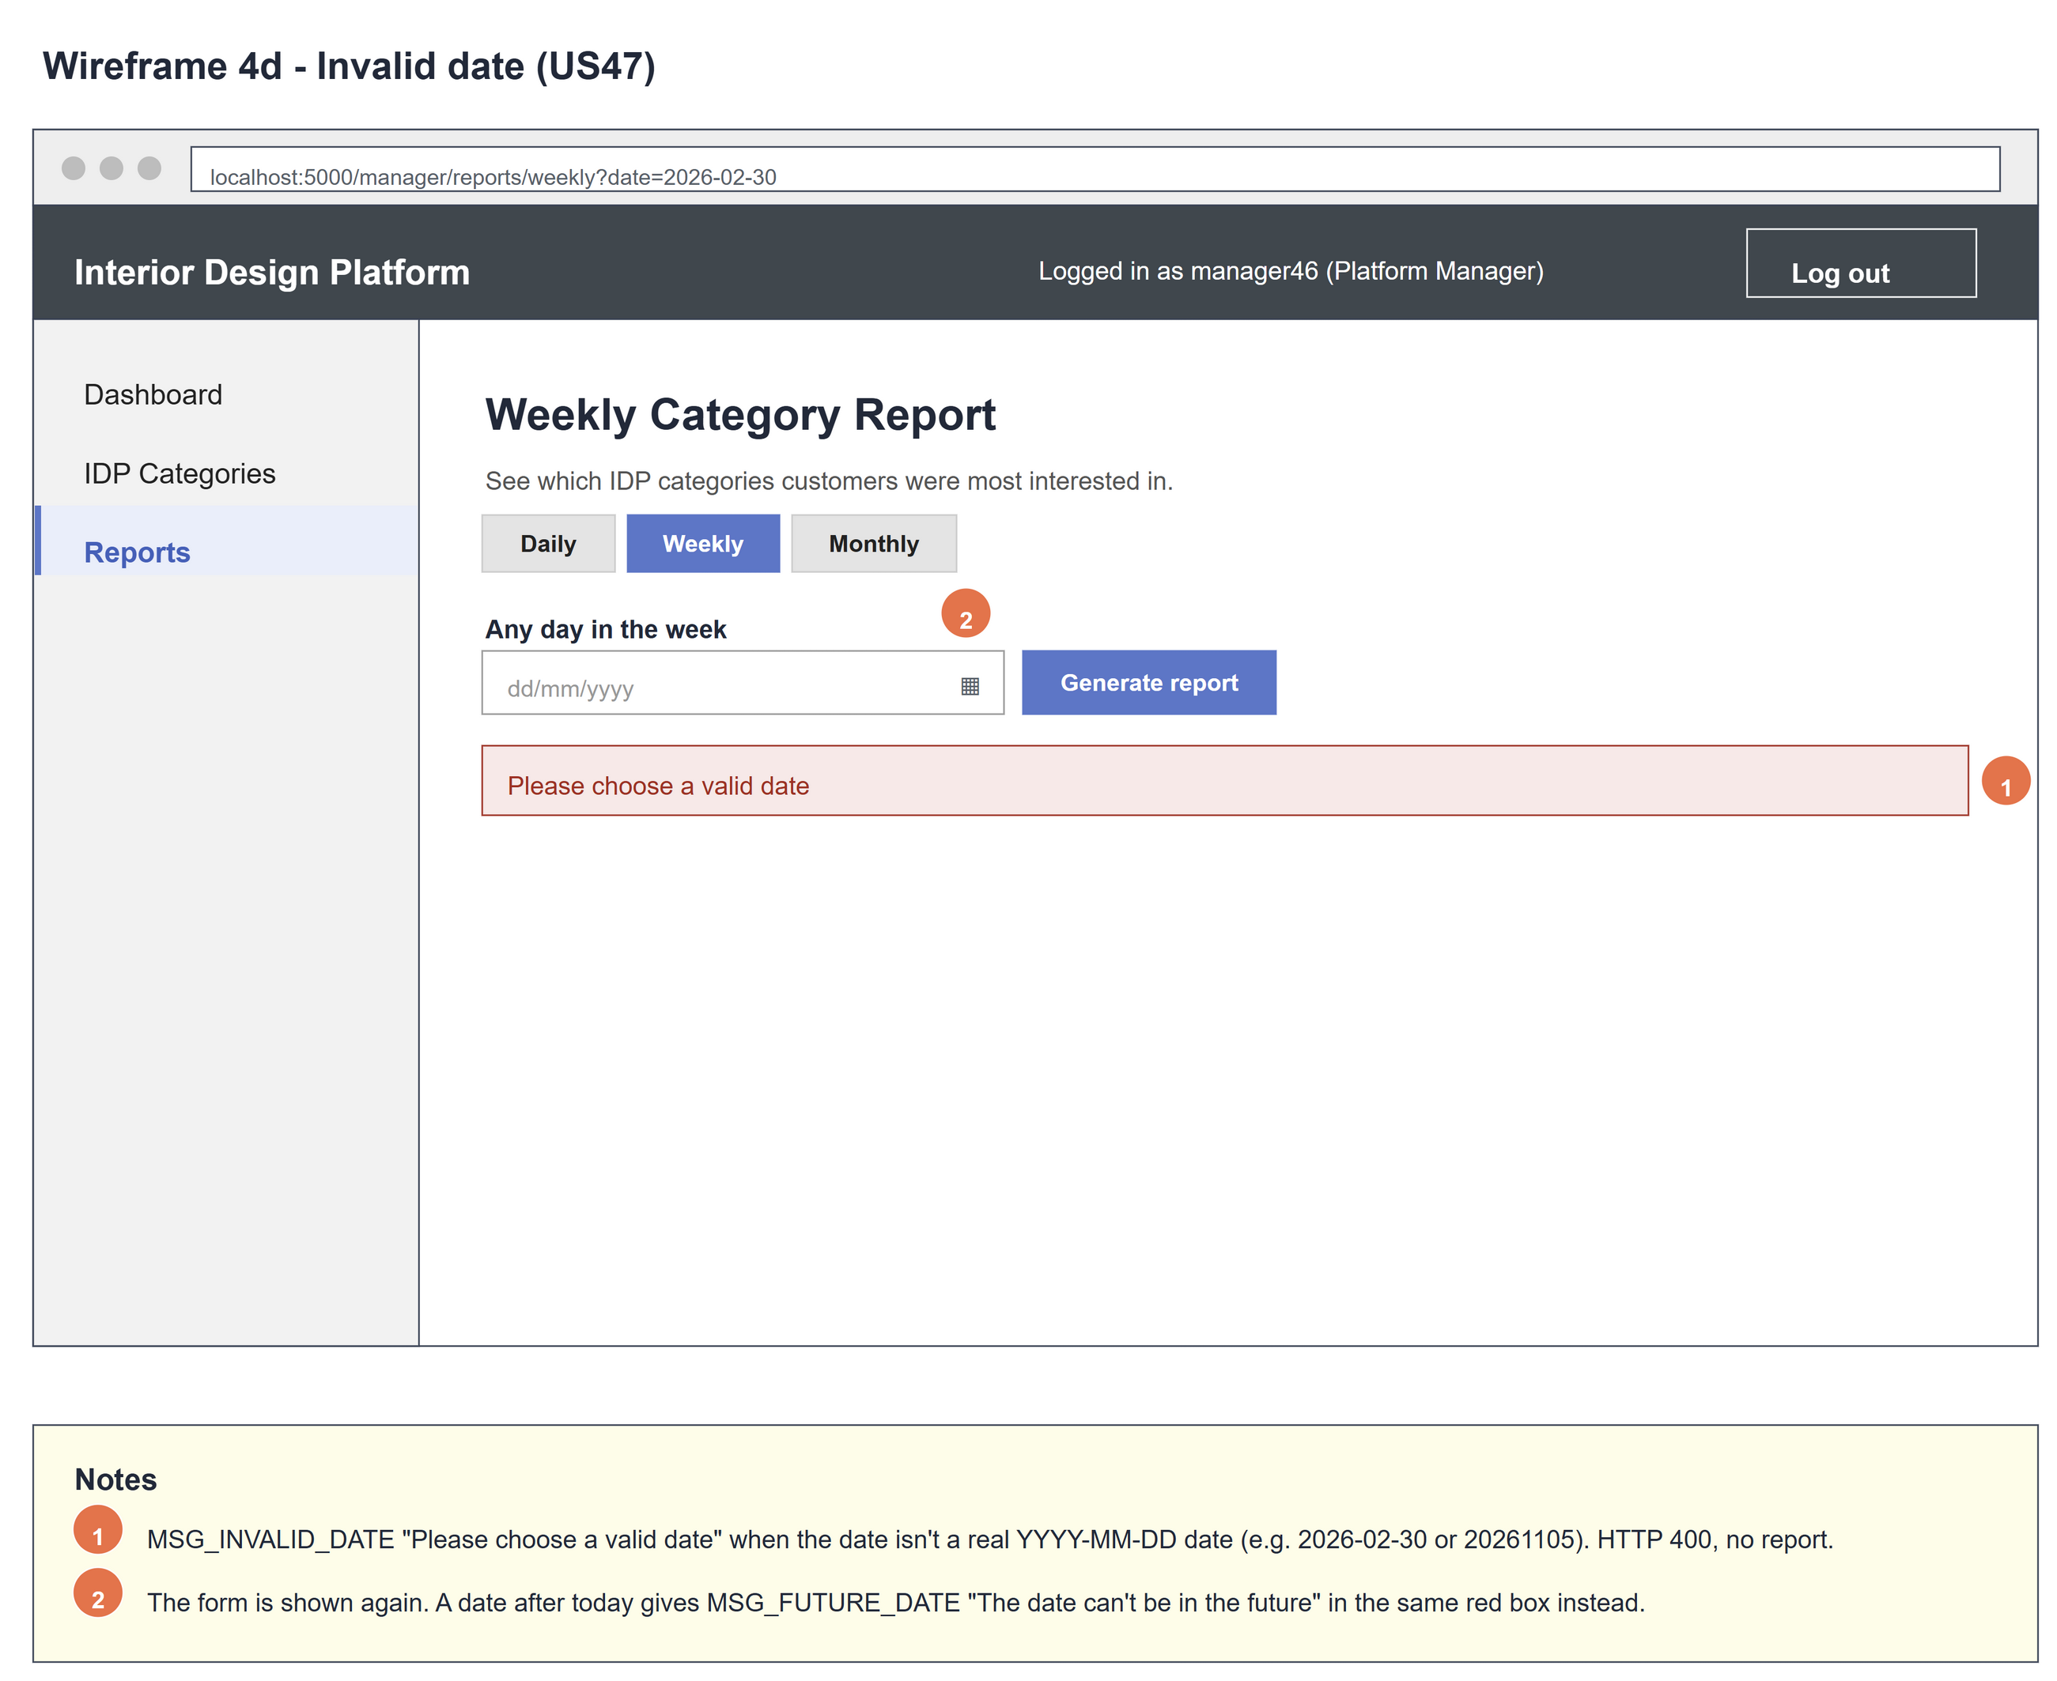
Figure 5: Wireframe 4d - Invalid date (US47)

5. B-C-E class diagram
The solid line means the boundary calls the controller. The dashed line means the controller uses the entity. Only the operations needed for this use case are shown. IDPAnalytics has the same attribute list in every Sprint 5 B-C-E diagram (US37, US38, US46 - US48): a report uses startDate, endDate and categories, and each category row uses categoryId, categoryName, status, totalIDPs, views and saves.
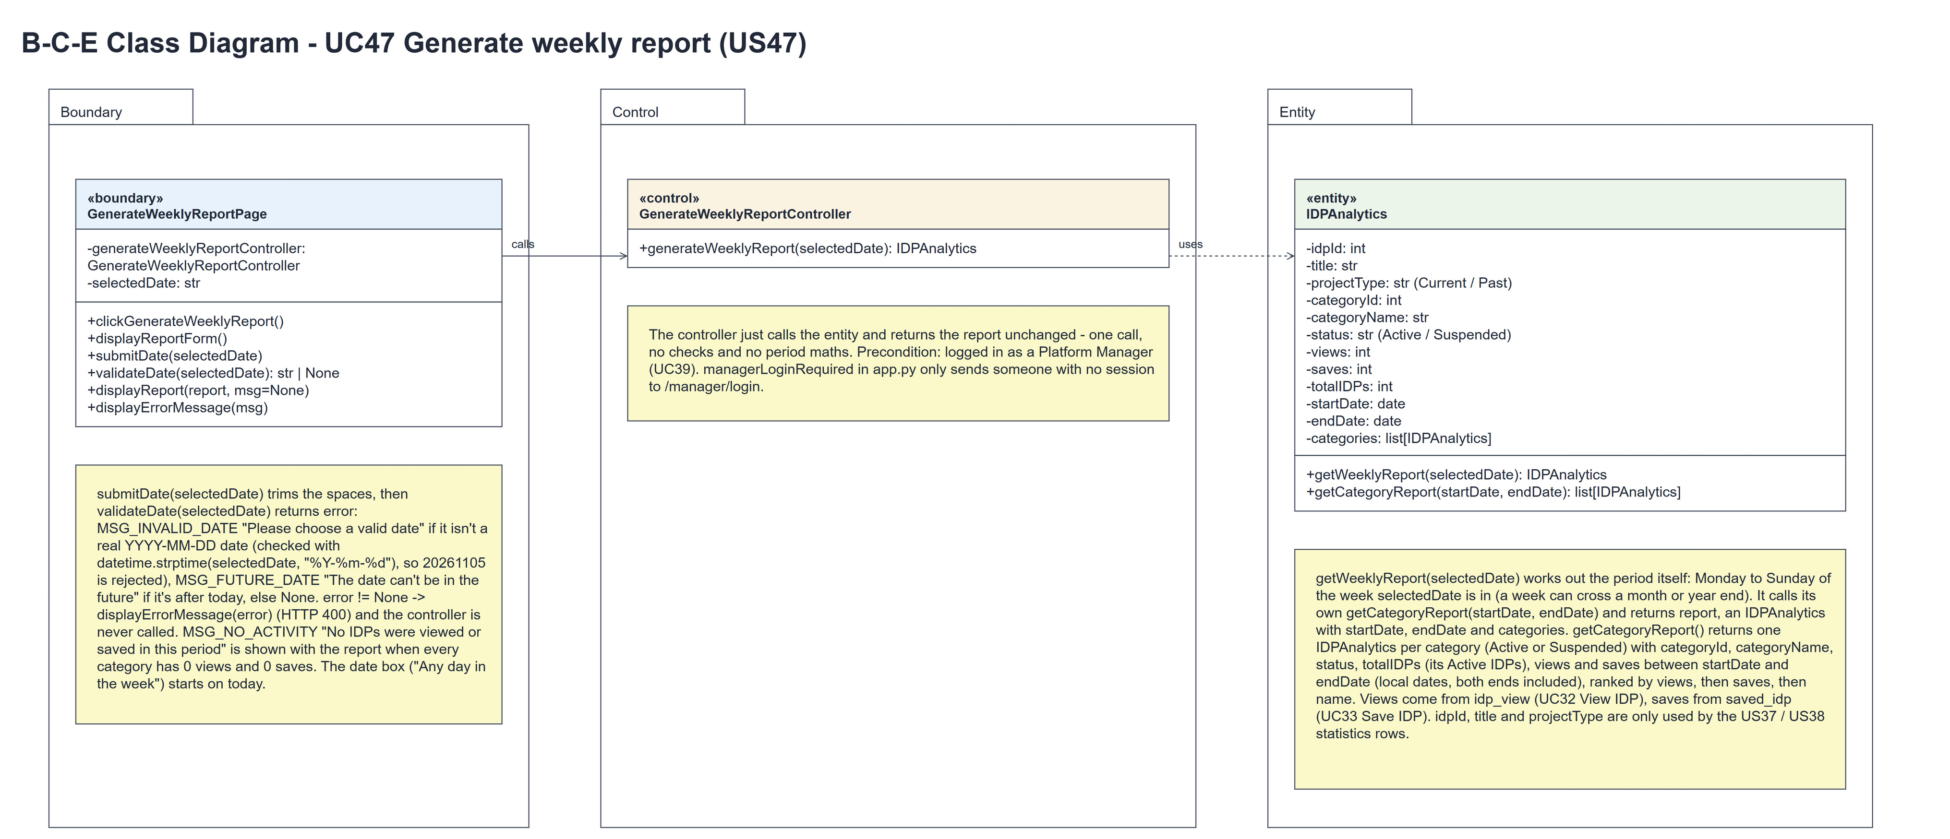
Figure 6: B-C-E class diagram for US47 Generate weekly report
Layer | Class | What it does
Boundary | GenerateWeeklyReportPage | The Weekly Category Report page. clickGenerateWeeklyReport() shows displayReportForm() with the date box on today. submitDate(selectedDate) trims the date and calls validateDate(selectedDate), which returns error (MSG_INVALID_DATE, MSG_FUTURE_DATE or None). An error -> displayErrorMessage(error) (HTTP 400) and the controller is not called. Otherwise it calls generateWeeklyReport(selectedDate) and shows displayReport(report), or displayReport(report, MSG_NO_ACTIVITY) when every category has 0 views and 0 saves.
Control | GenerateWeeklyReportController | Controller for UC47. generateWeeklyReport(selectedDate) just calls IDPAnalytics.getWeeklyReport(selectedDate) and returns the report unchanged - one call, no checks, no period maths.
Entity | IDPAnalytics | The only entity. getWeeklyReport(selectedDate) works out the period (Monday to Sunday of the week selectedDate is in), calls its own getCategoryReport(startDate, endDate) and returns report: an IDPAnalytics with startDate, endDate and categories (a list[IDPAnalytics], one per category with categoryId, categoryName, status, totalIDPs, views and saves, ranked by views, then saves, then name).

6. Sequence diagram
The sequence diagram follows UC47. Opening the page (steps 1-3) shows the date form. submitDate(selectedDate) (step 4) runs validateDate(selectedDate) (step 5), which returns error. Outer alt [error == None]: the page calls generateWeeklyReport(selectedDate) (step 6) and the controller makes one call, getWeeklyReport(selectedDate) (step 7); the entity works out the period (Monday to Sunday of the week selectedDate is in) and calls its own getCategoryReport(startDate, endDate) (step 8), and the report comes back unchanged (steps 9-10). The inner alt shows the ranked report (steps 11-12) or the report with MSG_NO_ACTIVITY (steps 13-14, alternative flow 7a). [error != None]: displayErrorMessage(error) and HTTP 400 (steps 15-16, alternative flows 4a and 4b) - the controller is never called.
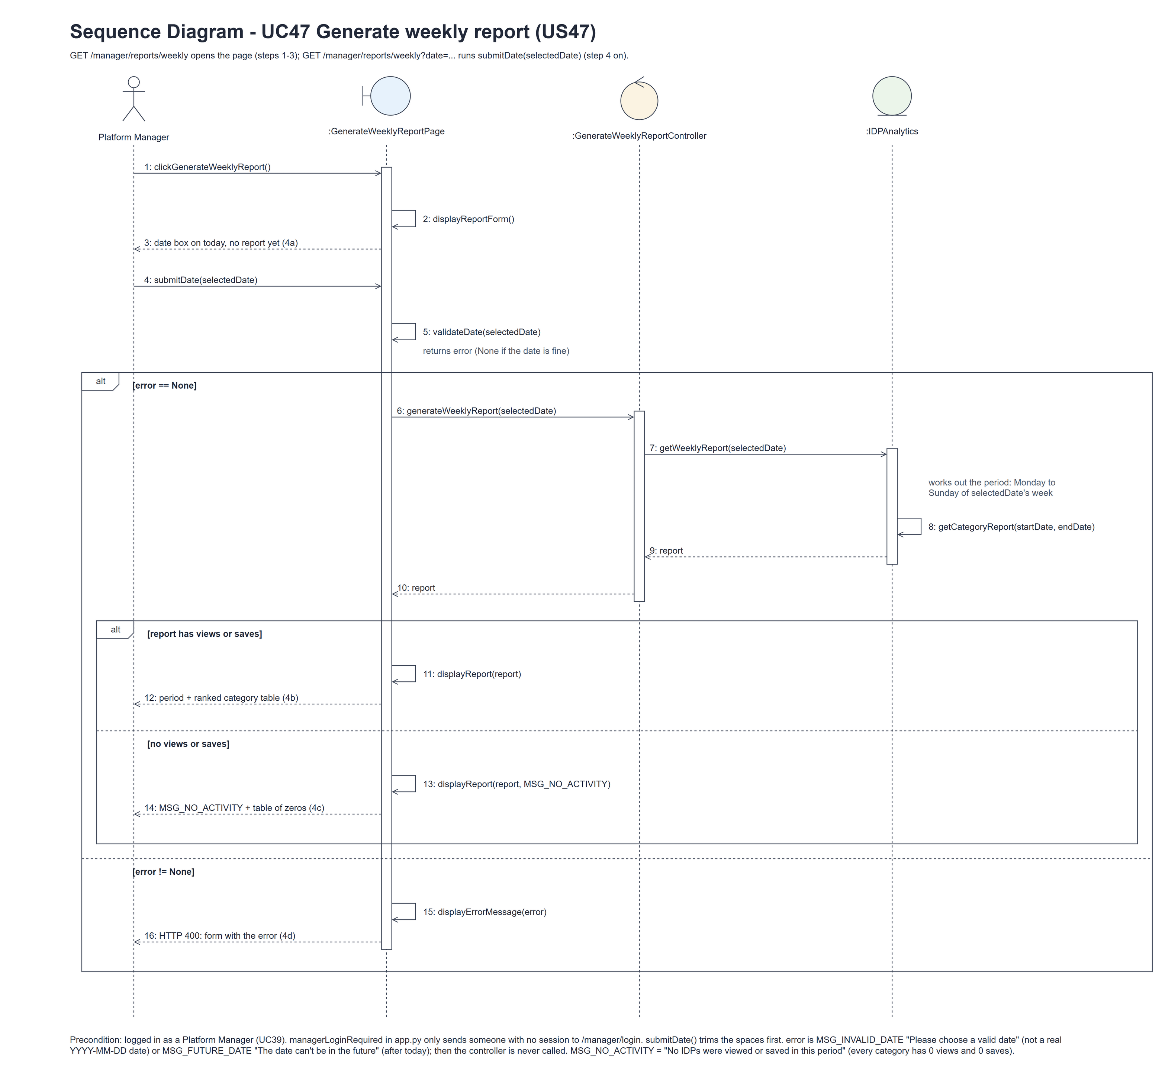
Figure 7: Sequence diagram for UC47 Generate weekly report

7. Test cases
Test data used below (the same as tests/test_us47_generateWeeklyReport.py, which reuses the US37 and US46 helpers): the manager account manager46 / Manager@123 (Platform Manager profile) and the designer designer37 / Design@123, both made with UC8. IDP categories Kitchen, Bedroom and Bathroom (Active). The IDPs "Modern Kitchen" (Kitchen) and "Cozy Bedroom" (Bedroom, Past). Views and saves are stored with UTC times: on 5 Nov 2026 Modern Kitchen has 3 views and 1 save (by cust001) and Cozy Bedroom 1 view, and Cozy Bedroom has 1 more view on 4 Nov 2026. Bathroom has none. Tests use an isolated database. 5 Nov 2026 is a Thursday, so its week is 2 - 8 Nov 2026.

7a. System test cases (black box)
Equivalence partitioning and boundary value analysis were used to pick the test data. Fill in "Actual result" and "Pass/Fail" after running each test.
Test ID | Scenario | Prerequisites | Test steps | Test data | Expected result | Actual result | Pass / Fail
TC47.1 | Open the weekly report | Logged in as manager46. | 1. Click the "Weekly" tab | - | "Weekly Category Report", the box "Any day in the week" on today; no table yet.
TC47.2 | Generate a weekly report | Test data above. | 1. Pick 05/11/2026 (a Thursday)  2. Click "Generate report" | 2026-11-05 | "Period: 02 Nov 2026 to 08 Nov 2026"; Kitchen (3 views, 1 save), Bedroom (2, 0), Bathroom (0, 0).
TC47.3 | Monday and Sunday give the same week | Test data above. | 1. Generate for 02/11/2026  2. Generate for 08/11/2026 | 2026-11-02, 2026-11-08 | Both show "02 Nov 2026 to 08 Nov 2026" with the same numbers.
TC47.4 | Other weeks not counted | Test data + 1 Kitchen view on Sun 1 Nov 2026. | 1. Generate for 05/11/2026 | 2026-11-05 | Kitchen still has 3 views (1 Nov is in the week before).
TC47.5 | Week across a year end | Logged in as manager46. | 1. Generate for 31/12/2025 | 2025-12-31 | "Period: 29 Dec 2025 to 04 Jan 2026".
TC47.6 | No activity | Categories exist; nothing viewed or saved from 19 to 25 Oct 2026. | 1. Generate for 20/10/2026 | 2026-10-20 | "No IDPs were viewed or saved in this period" and the table with zeros.
TC47.7 | Not a date | Logged in as manager46. | 1. Open /manager/reports/weekly?date=not-a-date | not-a-date | HTTP 400 "Please choose a valid date"; no report.
TC47.8 | Week-number format | Logged in as manager46. | 1. Open /manager/reports/weekly?date=2026-W45-4 | 2026-W45-4 | HTTP 400 "Please choose a valid date"; no report.
TC47.9 | Future date | Logged in as manager46. | 1. Generate for tomorrow | tomorrow's date | HTTP 400 "The date can't be in the future"; no report.
TC47.10 | Not logged in | Not logged in. | 1. Open /manager/reports/weekly | - | The manager login page is shown.

7b. Unit test cases (for TDD)
These are written before the code (test-driven development) and run automatically in the CI pipeline. They cover normal inputs, abnormal inputs and boundary values. Each one matches a test function in tests/test_us47_generateWeeklyReport.py (UT47.1 is test_ut47_1_...). Controller means GenerateWeeklyReportController; Boundary means GenerateWeeklyReportPage. "Pass" is from the pytest run on 10 November 2026.
Test ID | Class and method | Input / setup | Expected output | Type | Pass / Fail
UT47.1 | IDPAnalytics.getWeeklyReport(selectedDate) | Mon 2, Thu 5 and Sun 8 Nov 2026 | report.startDate 2 Nov 2026 and report.endDate 8 Nov 2026 each time | Normal | Pass
UT47.2 | IDPAnalytics.getWeeklyReport(selectedDate) | Thu 31 Dec 2026 | 28 Dec 2026 to 3 Jan 2027 (the week crosses a month and a year end) | Boundary | Pass
UT47.3 | IDPAnalytics.getWeeklyReport(selectedDate) | Test data + 1 Kitchen view on Sun 1 Nov; 5 Nov 2026 | report.categories: Kitchen (3, 1), Bedroom (2, 0), Bathroom (0, 0) - the whole week, not 1 Nov | Normal | Pass
UT47.4 | Boundary.submitDate() (GET ?date=2026-11-05) | Test data | HTTP 200, "02 Nov 2026 to 08 Nov 2026" and "Weekly Category Report" | Normal | Pass
UT47.5 | Boundary.validateDate() / displayErrorMessage() | ?date=not-a-date | HTTP 400, MSG_INVALID_DATE | Abnormal | Pass
UT47.6 | Boundary.clickGenerateWeeklyReport() (GET) | GET /manager/reports/weekly | "Any day in the week" shown; no table | Normal | Pass
UT47.7 | Controller.generateWeeklyReport(selectedDate) | 5 Nov 2026 | Makes one call to IDPAnalytics.getWeeklyReport(selectedDate) and returns that report unchanged | Normal | Pass
UT47.8 | Boundary.validateDate(selectedDate) | "20261105"; "2026-W45-4" | MSG_INVALID_DATE for both (strict YYYY-MM-DD) | Abnormal | Pass
UT47.9 | Boundary.displayReport() (GET ?date=...) | Categories with no views or saves, ?date=2026-10-20; then the test data, ?date=2026-11-05 | MSG_NO_ACTIVITY with the zero table; not shown when the week has views | Boundary | Pass

